LATITUDE AND LONGITUDE REFERENCE SYSTEM
4
3
6
2
5
1
6
5
4
3
2
1

SOUTH
EAST

81° 30’ 82° 30’ 83° 30’ 84° 30’ 85° 30’ 86°
29 °

30’

30°

30’

31°

30’

32°

30’

33°

Determine Latitude/Longitude Coordinates for the marked positions.
1. 2945S 08115E
2. 2930S 08430E
3. 3015S 08530E
4. 3145S 08315E
5. 3115S 08545E
6. 3245S 08445E
Plot the following Lat/Long Position. Ensure you label you plots with the corresponding number.
1. 2930S 08330E
2. 3015S 08315E
3. 3115S 08415E
4. 3230S 08230E
5. 2915S 08545E
6. 3045S 08445E


LATITUDE AND LONGITUDE REFERENCE SYSTEM
2
6
5
1
4
3
6
5
4
3
2
1
SOUTH
81° 30’ 80° 30’ 79° 30’ 78° 30’ 77° 30’ 76°
29 °

30’

30°

30’

31°

30’

32°

30’

33°
West

Determine Latitude/Longitude Coordinates for the marked positions.
1. 2915S 07830W
2. 2930S 07715W
3. 3030S 08045W
4. 3030S 07615W
5. 3145S 07730W
6. 3215S 07745W
Plot the following Lat/Long Position. Ensure you label you plots with the corresponding number.
1. 3015S 08045W
2. 3145S 07745W
3. 2930S 07830W
4. 2930S 07745W
5. 3045S 08045W
6. 3030S 07730W

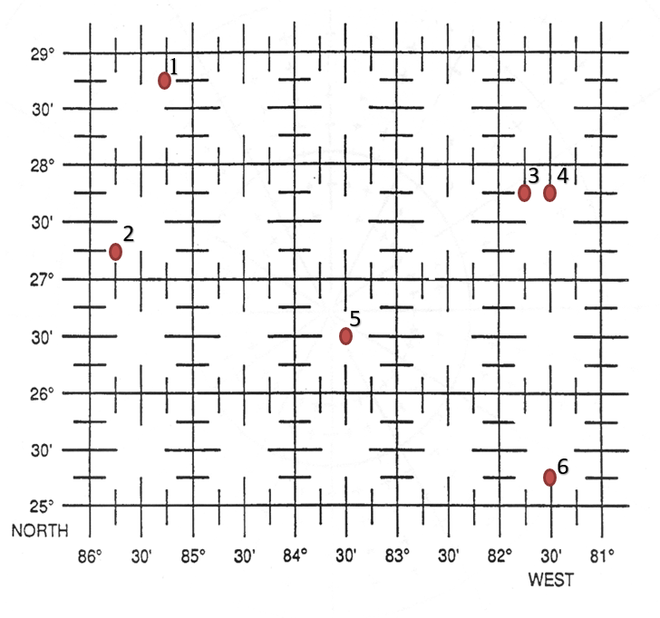
LATITUDE AND LONGITUDE REFERENCE SYSTEM
6
3
5
2
4
1

Determine Latitude/Longitude Coordinates for the marked positions.
1. 2845N 08515W
2. 2715N 08545W
3. 2745N 08145W
4. 2745N 08130W
5. 2630N 08330W
6. 2515N 08130W
Plot the following Lat/Long Position. Ensure you label you plots with the corresponding number.
1. 2830N 08345W
2. 2715N 08330W
3. 2545N 08415W
4. 2715N 08530W
5. 2530N 08545W
6. 2515N 08415W

